**Chapter 1**

**INTRODUCTION**

* 1. **Overview**

Cardiovascular disease is one of the main causes of the death in many countries and thus it accounts for the over 15 million deaths worldwide. In addition, several million people are disabled by cardiovascular disease (WHO, 1999). Monitoring of the patients is one possible solution. This disease has shown that heart beat rate plays a key role in the risk of heart attack. Most of time, heart disease problems harm the elderly person. Many seniors citizens prefer to live independently in their home but they face many difficulties when their caretakers (son/daughter) is not around. This trend towards an independent lifestyle has also increased the demand for personalized non-hospital based care.

According to a survey on aging population by United Nation, the world population is expected to double from 35 million people to 75 million people from the year 2010 to 2050. Considering the fact that 89% of the senior citizens like to be in their homes, even at more risk to their health security and safety. Several companies have taken initiatives to develop smart senior care technologies into home.

This project “ARISTA” can be used in hospitals and also for patients who can be under continuous monitoring while travelling from place to place. Since the system is continuously monitoring the patient and in case of any abnormal in the heart beat rate of the patient the system will immediately message to the concerned doctors about the condition of the patient and abnormal details. To perform these operations the system uses heart beat sensor, GSM modem, and to control all these devices, arduino is used.

* 1. **Proposed System**

In this project we have a system which consists of a prototype and a mobile application. The proposed system will improve the quality of life of seniors. The prototype has several features, such as monitoring heart rate, sending Emergency alert message to registered and nearby people along with the location of the victim. These features are operated using push buttons provided in the prototype. Whenever the senior citizen fall into trouble, any fluctuations in their health or they may need someone’s help, in such cases Senior citizen can press the Emergency button in the prototype which will send the message to the mobile application. The mobile application which is maintained by the registered peoples will receive this emergency message as the notification so that they can take further actions. Another feature is monitoring of heart rate. The system is able to monitor and alert the patient’s relevant doctors about the patient’s heartbeat conditions.

* 1. **Scope for work**

Long waiting time for hospitalization or ambulatory patient monitoring/treatment, are other well-known issues for both the healthcare and patients. In metropolitan cities where there will be traffics at high peak, taking of patients to the hospital or arrival of doctor to the location takes long time. The patients cannot even move freely due to sense of danger. This project mainly focuses on providing security the senior citizens. There will be a constant monitoring of heart rate of the patients because of which they can move from place to place without any worries. The alert button in his project will serve as security. The patients can press the button whenever they sense danger. The alert message will be sent to the guardian as well as the nearby registered people who can provide help immediately.

**Chapter 2**

**LITERATURE SURVEY**

In recent year, there are many implementation is going for the smart healthcare and android application for the senior citizens.

K Aziz, S Tarapaih, SH Ismail, S Atalla,”Smart real-time healthcare monitoring and tracking system using GSM/GPS technologies”-2016 [1] Health monitoring systems have rapidly evolved recently, and smart systems have been proposed to monitor patient current health conditions, in our proposed and implemented system, we focus on monitoring the patient's blood pressure, and his body temperature. Based on last decade statistics of medical records, death rates due to hypertensive heart disease, shows that the blood pressure is a crucial risk factor for atherosclerosis and ischemic heart diseases; thus, preventive measures should be taken against high blood pressure which provide the ability to track, trace and save patient's life at appropriate time is an essential need for mankind. Nowadays, Globalization demands Smart cities, which involves many attributes and services, such as government services, Intelligent Transportation Systems (ITS), energy, health care, water and waste. This paper proposes a system architecture for smart healthcare based on GSM and GPS technologies. The objective of this work is providing an effective application for Real Time Health Monitoring and Tracking. The system will track, trace, monitor patients and facilitate taking care of their health; so efficient medical services could be provided at appropriate time. By Using specific sensors, the data will be captured and compared with a configurable threshold via microcontroller which is defined by a specialized doctor who follows the patient; in any case of emergency a short message service (SMS) will be sent to the Doctor's mobile number along with the measured values through GSM module. Furthermore, the GPS provides the position information of the monitored person who is under surveillance all the time. Moreover, the paper demonstrates the feasibility of realizing a complete end-to-end smart health system responding to the real health system design requirements by taking in consideration wider vital human health parameters such as respiration rate, nerves signs ... etc. The system will be able to bridge the gap between patients - in dramatic health change occasions- and health entities who response and take actions in real time fashion.

S Gowrishankar, MY Prachita, A Prakash, “IOT based Heart Attack Detection, Heart Rate and Temperature Monitor”-2017 [2]The Internet of Things (IOT) is intercommunication of embedded devices using networking technologies. The IOT will be one of the important trends in future; can affect the networking, business and communication. In this paper, proposing a remote sensing parameter of the human body which consists of pulse and temperature. The parameters that are used for sensing and monitoring will send the data through wireless sensors. Adding a web based observing helps to keep track of the regular health status of a patient. The sensing data will be continuously collected in a database and will be used to inform patient to any unseen problems to undergo possible diagnosis. Experimental results prove the proposed system is user friendly, reliable, economical.

Microcontroller Based Heart Beat Monitoring and Alerting System by Mayank Kothari Assistant Professor NMIMS, MPSTME Shirpur, India-2015 [3]It explains how a single-chip microcontroller can be used to analyze heart beat rate in real-time. In addition, it allows doctors to get the heart beat and location of the patient by GSM every twenty four hours. It can also be used to control patients or athletic person over a long period. The system reads stores and analyses the heartbeat repetitively in real-time. The hardware and software design are oriented towards a single-chip microcontroller-based system, hence minimizing the size. The hardware design is based on an embedded system implementation using the PIC16F877 (a 40 bit) microcontroller from microchip. This system consist of Microcontroller (PIC16F877A), heart beat sensor, GSM modem, GPS receiver. For measuring Heartbeat, input is taken from the finger. Heart beat sensor will generate digital pulse corresponding to each beat. This pulse is counted by interfacing heart beat sensor to microcontroller to pin no. 15(TICKL) and programming the microcontroller in counter mode. After counting of pulse for one minute, value of heart beat will be displayed on LCD and if value is beyond the normal range then location of patient will be messaged to doctor or health attendant personnel using GSM.

WM Jubadi, SFAM Sahak, “Heartbeat Monitoring Alert via SMS”-2009 [4] The heart rate can be measured by monitoring one's pulse using specialized medical devices such as an electrocardiograph (ECG), portable device e.g. wrist strap watch, or any other commercial heart rate monitors which normally consisting of a chest strap with electrodes. Despite of its accuracy, somehow it is costly, involve many clinical settings and patient must be attended by medical experts for continuous monitoring. For a patient whom already diagnosed with fatal heart disease, their heart rate condition has to be monitored continously. This paper proposed an alert system that able to monitor the heart beat rate condition of patient. The heart beat rate is detected using photoplethysmograph (PPG) technique. This signal is processed using PIC16F87 microcontroller to determine the heart beat rate per minute. Then, it sends sms alert to the mobile phone of medical experts or patient’s family members, or their relatives via SMS. Thus, doctors can monitor and diagnose the patient’s condition continously and could suggest earlier precaution for the patients themselves. This will also alert the family members to quickly attend the patient.

**Chapter 3**

**ARCHITECTURE**

The System Architecture has different phases as shown in the Figure 3.1.

NODEMCU

SMART PHONE

GSM MODEM

HEART RATE SENSOR

*Figure 3.1 System Architecture*

**3.1 Prototype**

It is used to control the various features. It consists of Heart rate sensor, NodeMcu, GSM modem, Push button.

**3.1.1 Heart rate sensor**

A heart rate sensor is a personal monitoring device that allows one to measure ones heart rate in real time or record the heart rate for later study.

**3.1.2 Node MCU**

Node MCU is an open source IOT platform. It includes firmware which runs on the ESP8266 Wi-Fi SoC from Espressif Systems, and hardware which is based on the ESP-12 module.

**3.1.3 Push Button**

A push button is a simple switch mechanism for controlling some aspect of a machine or a process. It is used to send appropriate signals to the controller.

**3.1.3 GSM Modem**

A GSM modem is a specialized type of modem which accepts a SIM card, and operates over a subscription to a mobile operator, just like mobile phone

**3.2 Android Application**

An Android application is a software application running on the Android platform. Because the Android platform is built for mobile devices, a typical Android application is designed for a smartphone or a tablet PC running on the Android OS.

**Chapter4**

**SYSTEM REQUIREMENTS**

**4.1 Software Specification**

* Operating System: Microsoft Windows 10/8.1/8/8/7 (32 or 64 bit).
* Platform: Android Studio, Arduino
* Language: Java, PHP , XML

**4.2 Hardware Specification**

* Heart rate sensor
* GSM modem
* Node MCU
* Push button
* Battery

**Chapter 6**

**METHODOLOGY**

Internet of Things (IoT) is one of the promising technologies which can be used for connecting, controlling and managing intelligent objects which are connected to Internet through an IP address. Applications ranging from smart governance, smart education, smart agriculture, smart health care, smart homes etc can use IoT for effective delivery of services without manual intervention in a more effective manner.

Devices may be connected through a home network to allow control by a personal computer, and may allow remote access from the internet. Connect devices and appliances in your home so they can communicate with you. Give command by remote control, tablet or Smartphone, the home reacts. Applications relate to lighting, home security, home theater and entertainment etc.

**6.1 Node MCU**

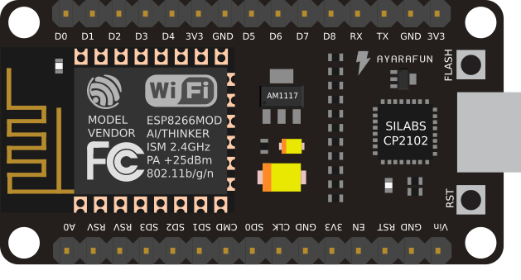

*Figure 6.3: Node MCU*

**6.4 Heart rate Sensor**

Heartbeat is sensed by using a high intensity type LED and LDR. The change in volume caused by the pressure pulse is detected by illuminating the fingertip’s skin with the light from an LED using a photodiode sensor. With each heart beat, a surge of blood is forced through the vascular system, expanding the capillaries in the finger, and changing the amount of light returning to the photodetector [5].

Very small changes in reflectivity or in transmittance caused by the varying blood content of human tissue are almost invisible. Valid pulse measurement therefore requires extensive preprocessing of the raw signal. A suitable operational amplifier is needed to amplify the heartbeat signal, due to its very low amplitude compare to the surrounding noise. For this project, LM358 is chosen. A super bright LED is suggested in the circuit as it can also perform well as light sensor. An LDR, whose resistance changes in response to the amount of light shining on it is employed to perform as photodiode sensor. The overall effect is that as illumination increases, the LDR resistance falls.



*Figure 6.4(a): Heart rate sensor*

The Pulse sensor converts the physical PPG into electrical signals. The sensor outputs a raw signal of analog voltage fluctuations amplifies it and normalizes the wave at V/2.

With every beat of the heart, a pulse wave travel along all arteries to the tissues where the Pulse Sensor is attached.

When this pulse wave goes under the sensor, the signal experiences a rapid upward rise in its value. It falls back down toward the normal point and before the next pulse sensor goes under the sensor, the signal stabilizes to the ambient noise.

Due to the repetitive characteristic of the pulse wave, the peak is chosen as a reference point because it’s recognizable. By applying calculation algorithm on the time between each two successive peaks the heart rate is measured. Ideally we want to find the instantaneous moment of the heart beat for accurate measurements.

This is implemented by interfacing the pulse sensor with the Arduino board as shown in Figure 6.4(b) .



*Figure 6.4(b): Heart rate sensor*

**6.5 GSM Module**

A GSM modem is a specialized type of modem which accepts a SIM card, and operates over a subscription to a mobile operator, just like a mobile phone. From the mobile operator perspective, a GSM modem looks just like a mobile phone.

When a GSM modem is connected to a computer, this allows the computer to use the GSM modem to communicate over the mobile network.  While these GSM modems are most frequently used to provide mobile internet connectivity, many of them can also be used for sending and receiving SMS and MMS messages.A GSM modem can be a dedicated modem device with a serial, USB or Bluetooth connection, or it can be a mobile phone that provides GSM modem capabilities.

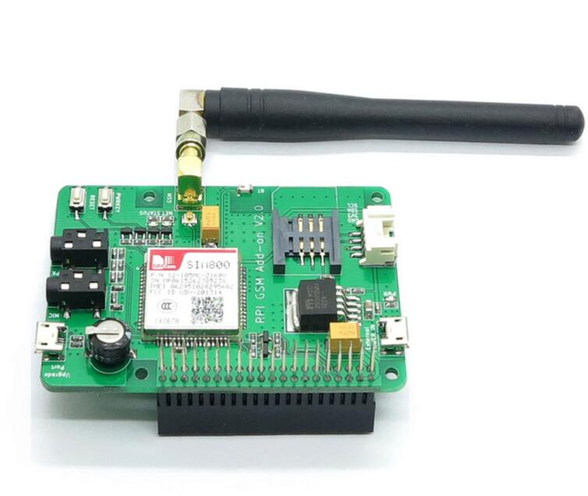

*Figure 6.5:GSM Modem*

**6.6 Android Studio**

Android Studio is the official integrated development environment (IDE) for the Android platform. Android Studio is freely available under the Apache License 2.0. The first stable build was released in December 2014, starting from version 1.0. Based on JetBrainsIntelliJ IDEA software, Android Studio is designed specifically for Android development. It is available for download on Windows, Mac OS X and Linux, and replaced Eclipse Android Development Tools (ADT) as Google’s primary IDE for native Android application development.

An integrated development environment (IDE) is a software application that provides comprehensive facilities to computer programmers for software development. An IDE normally consists of a source code editor, build automation tools and a debugger.

**6.6.1Android Programming Basics**

The basic programming language need to develop an Android application is Java programming language. Android is an open source framework, therefore Google has created a website to assist developer build Android Applications. In the website, Android SDK can be downloaded link Android SDK provides libraries needed to interface with hardware.Java is used to design backend and XML is used for frontend design.

**6.6.2 JAVA**

Java is a general purpose computer programming language that is concurrent, class based, object-oriented and specifically designed to have as few implementation dependencies as possible. Java is one of the most popular programming languages in use, particularly for client-server web applications.

**6.6.2.1Features**

1. **Simple:** Java language is simple because syntax is baesd on C++. No need to remove unreferenced object because there is Automatic Garbage collection in Java.
2. **Object-Oriented:** Object-oriented means we organize our software as a combination of different types of objects that incorporates both data and behavior.
3. **Platform independent:** Java provides software-based platform. The Java platform differs from most other platforms in the sense that it’s a software-based platform that runs on top of other hardware-based platforms.
4. **Secured:** Java is secured programming language because

* No explicit pointer
* Program run inside virtual machine sandbox

1. **High Performance:** Java is faster than traditional interpretation.

**6.6.3 XML**

Extensible Markup Language (XML) is used to describe data. The XML standard is a flexible way to create information formats and electronically share structured data via the public Internet, as well as via corporate networks. XML code, a formal recommendation from the World Wide Web Consortium (W3C), is similar to Hypertext Markup Language (HTML). Both XML and HTML contain markup symbols to describe page or file contents. HTML code describes Web page content only in terms of how it is to be displayed and interacted with.

**6.7 Database Server**

We are using database server to interface between the app and the smart wrist band. We can retrieve or update the value in android application and wrist band. We are using 000webhost which provides free web host features like PHP, MySQL. PHP is used for server side scripting language.

**6.7.1 PHP**

PHP is a server-side scripting language designed primarily for web development but also used as a general-purpose programming language. PHP code may be embedded into HTML or HTML5 markup, or it can be used in combination with various web template systems, web content management systems and web frameworks. PHP code is usually processed by a PHP interpreter implemented as a module in the web server or as a Common Gateway Interface (CGI) executable. The web server software combines the results of the interpreted and executed PHP code, which may be any type of data, including images, with the generated web page. PHP code may also be executed with a command-line interface (CLI) and can be used to implement standalone graphical applications.

**6.8 Implementation**

The main modules of ARISTA are:

* Heart rate monitoring.
* Nearby band detection and alert messages to registered users of smartband app.

.

**Module 1**:

* Provides heart beat prototype for supporting the preliminary medical support.
* Here the study of heart beat and pulse signal which are used along with hardware and software is made.
* The heart beat data is recorded into database.
* Prototype can be used in clinical lab with 95% accuracy and cheaper price.

**Module 2**:

* The interested user must register into the app.
* They will be notified through alert message with exact location of the smart band user who initially made request for help.

**Chapter 7**

**RESULT**

The following shows the operations of the prototype and the Mobile Application.

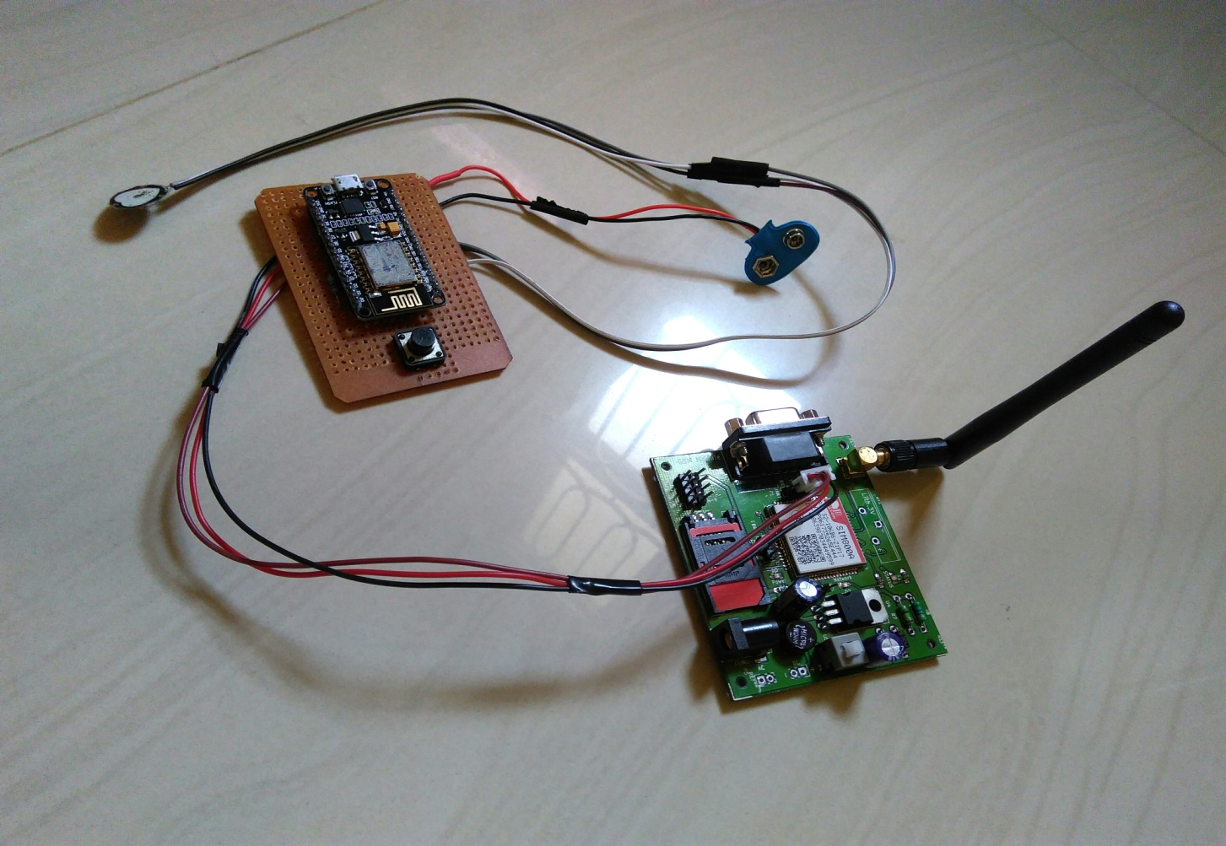

*Fig 7.1Working model of our system*

Fig 7.1 shows the working prototype our system which monitors the heart rate and sends alert.

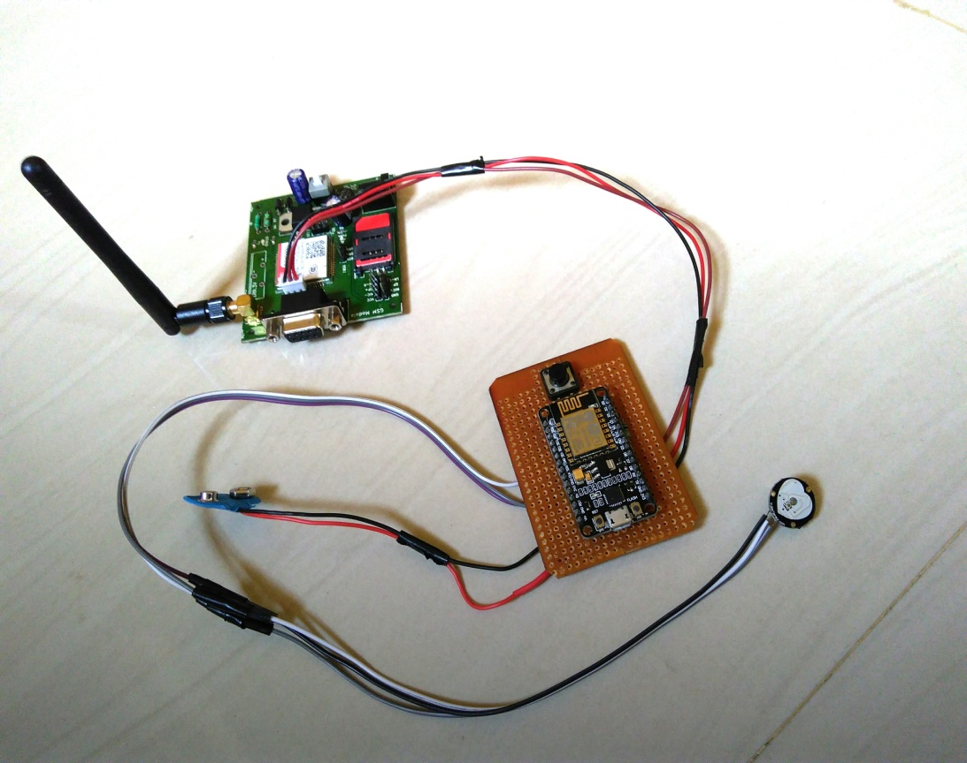

*Fig7.2Jumpers used in system*

Fig 7.2 shows how components are connected with the help of jumpers and there by sends alert messages through gsm model to the registered people in the android app.

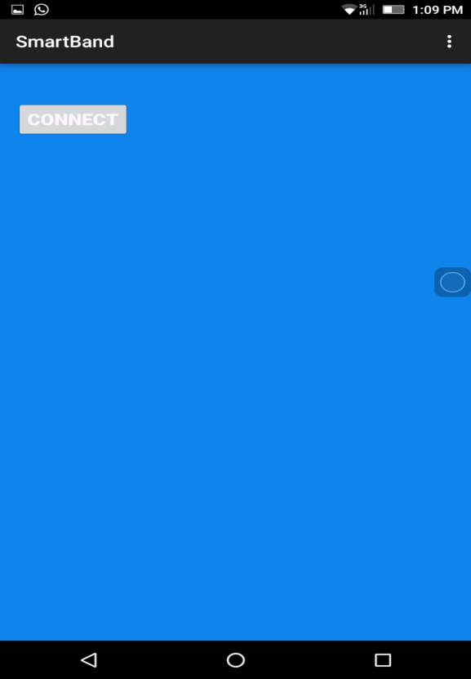 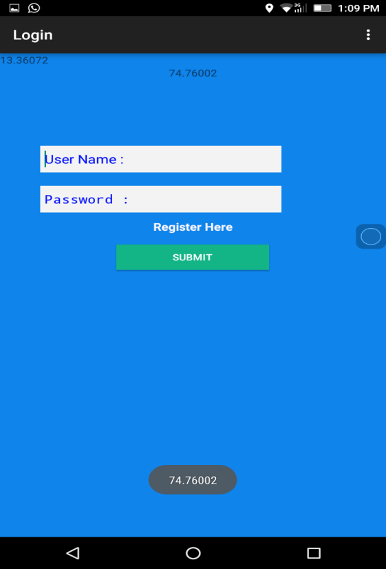

*Fig 7.6 Home Page Fig 7.7 Login Page*

The Fig 7.6,7.7 shows the home page and log-in page for the customers through the mobile application. The Fig. 7.8 shows the Main page which consists of three options. The user can select the suitable option from his android based mobile app as per the requirement.

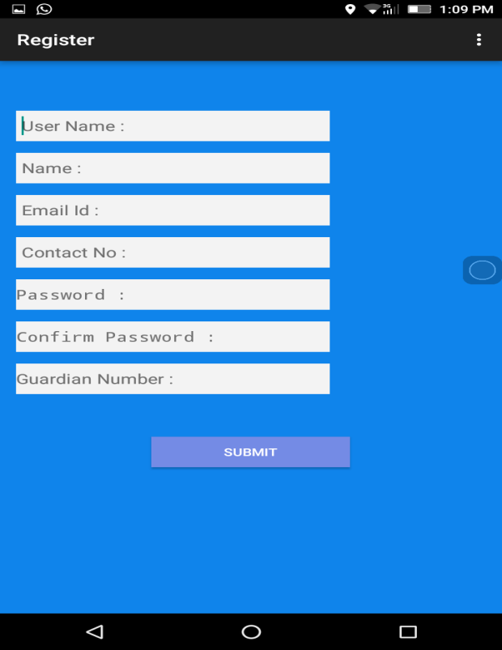

*Fig 7.8 Register Page*

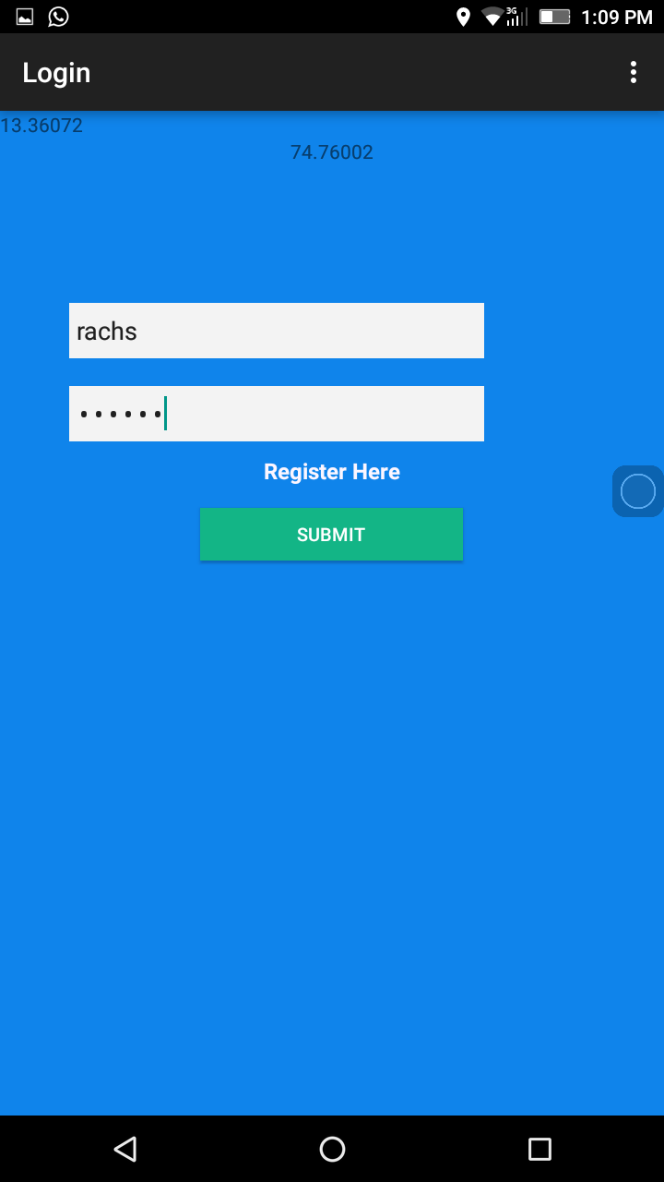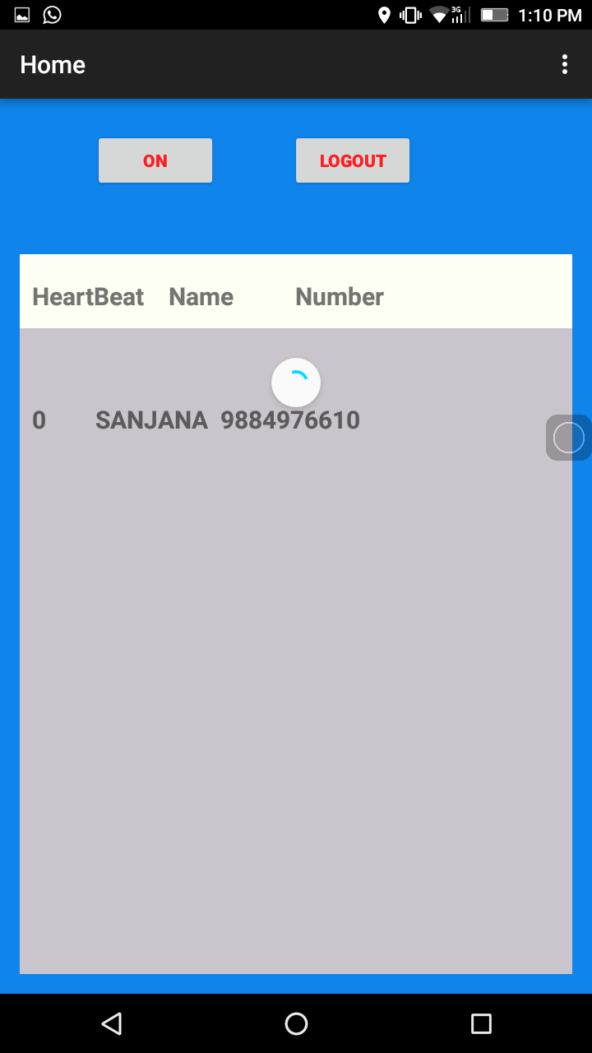

*Fig 7.9 Login page Fig 7.10 Main page*

Figure 7.9 shows the login page with username and password entered. On submitting the correct username and password the next main page will be displayed as shown in figure 7.10. The main page conists of patient’s heart rate along with on button that sends alert to registered number along with nearby people.

**Chapter 8**

**CONCLUSION AND FUTURE ENHANCEMENT**

This project is used to help senior citizen to improve the quality of living in their respective home. We have implemented device for senior citizens to monitor their heart rate condition, and also can send the emergency message to the caretaker which will be received by the caretaker. The main benefit of this project is even nearby people can get alert when the patient is in danger. The mobile application helps caretaker to monitor and assist the senior citizen.

Although the final products were very successful at accomplishing the objectives, it must be kept in mind that the products produced are simple prototypes and much more work would need to be done to create a marketable product. Several areas that need to be improved are the size of the devices, the cost of the devices, the power sources used and the range of communication.

Another area to help improve the size is the circuit board that is used. If this device were to be commercially produced, a more compact circuit board could be designed.

**REFERENCES**

[1] K Aziz, S Tarapaih, SH Ismail, S Atalla,”Smart real-time healthcare monitoring and tracking system using GSM/GPS technologies”-2016

[2] S Gowrishankar, MY Prachita, A Prakash, “IOT based Heart Attack Detection, Heart Rate and Temperature Monitor”-2017

[3] Microcontroller Based Heart Beat Monitoring and Alerting System by Mayank Kothari Assistant Professor NMIMS, MPSTME Shirpur, India-2015

[4] WM Jubadi, SFAM Sahak, “Heartbeat Monitoring Alert via SMS”-2009

[5] Shelley, K. H., R. G. Stout, et al. (1999). "The Use of Joint Time Frequency Analysis of The Pulse Oximeter Waveform to Measure The Respiratory Rate of Ventilated Patients." Anesthesiology 91(3A): A583.